**The Coronavirus Fight课后作业**

1. **观看视频，熟读下列单词：**
2. coronavirus冠状病毒
3. fight打仗；斗争 light轻的；灯 bright明亮的；聪明的
4. fair公平的 air空气 hair头发 chair椅子
5. sick生病的，不舒适的 chick小鸡 thick厚的
6. close靠近，紧密 nose鼻子 rose玫瑰 those那些
7. hide隐藏 beside在...旁边 outside在...外面
8. scrub用力擦洗 rub擦，摩擦 rubber橡皮
9. **观看视频，选择正确答案。**

[](https://pic.sogou.com/d?query=%C7%B1%CB%AE%BF%A8%CD%A8%CD%BC%C6%AC%26mode=1%26did=1)[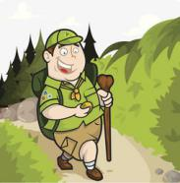](https://pic.sogou.com/d?query=%B5%C7%C9%BD%BF%A8%CD%A8%CD%BC%C6%AC%26mode=1%26did=24)[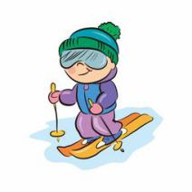](https://pic.sogou.com/d?query=%BB%AC%D1%A9%CD%BC%C6%AC%BF%A8%CD%A8%26mode=1%26did=3)( )1. We cancel(取消) the trip(旅行) to .

A. B. C.

[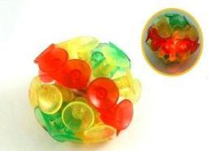](https://pic.sogou.com/d?query=%CE%FC%C5%CC%C7%F2%26mode=1%26did=3)( )2. The coronavirus looks like (看起来像) a .

[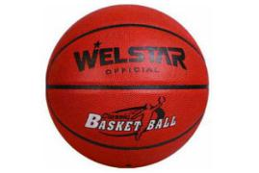](https://pic.sogou.com/d?query=basketball%26mode=1%26did=8)[](https://pic.sogou.com/d?query=%C6%B9%C5%D2%C7%F2%26mode=1%26did=22)A. B. C.

[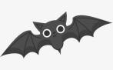](https://pic.sogou.com/d?query=%F2%F9%F2%F0%BF%A8%CD%A8%26mode=1%26did=82)( )3. We cannot get **close** to . It’s not good for us.这里的“close”是什么意思？

A. 关上，关闭 B. 靠近，紧密 C.远离，隔开

[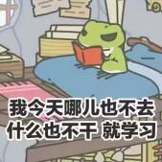](https://pic.sogou.com/d?query=%B3%F6%C3%C5%26mode=1%26did=216)[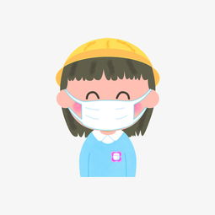](https://pic.sogou.com/d?query=%B4%F7%BF%DA%D5%D6%26mode=1%26did=4)( )4. What should(应该) we do to protect ourselves(保护自己) ?

[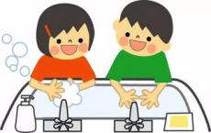](https://pic.sogou.com/d?query=%C7%DA%CF%B4%CA%D6%26mode=1%26did=32)A. B. C. D. A and B and C

[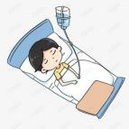](https://pic.sogou.com/d?query=%B2%A1%C8%CB%BF%A8%CD%A8%26mode=1%26did=40)[](https://pic.sogou.com/d?query=%D2%BD%C9%FA%BB%A4%CA%BF%BF%A8%CD%A8%26mode=1%26did=4)( )5. Which one is wrong(错的)?

A.Many are helping .

B.The coronavirus is only in Wuhan.

[](https://pic.sogou.com/d?query=%B4%F7%BF%DA%D5%D6%26mode=1%26did=4) C.We cannot eat wild(野生) animals.

D.We must(必须) when we go out.

1. **把你在视频中学到的东西向家人讲述。（尽量英文，可中英结合。）**