**Cinderella课后作业**

1. **观看绘本视频，根据释义理解绘本内容。**

|  |  |  |  |
| --- | --- | --- | --- |
| 1.sweep the floor | 扫地 | 2.wash clothes | 洗衣服 |
| 3.take good care of | 照顾好··· | 4.be ready to··· | 准备好··· |
| 5.all of a sudden | 突然 | 6.mean | 刻薄的 |
| 7.leave | 离开 | 8.pick up | 捡起 |
| 9.show up | 出现 |  |  |

1. **观看视频，熟读下列单词。**

|  |  |  |  |
| --- | --- | --- | --- |
| 1.pretty 漂亮的 | 2then 然后 | 3.help 帮助 | 4.get 得到 |
| 5.clean 清扫 | 6.say 说 | 7.kind 友好的 | 8.find 寻找 |

1. **观看视频，选择正确答案**

( )1.The stepmother and stepsisters are very ____________.

1. pretty and kind B.mean C.busy

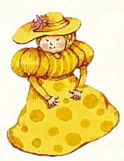( )2.Who helps Cinderella?

1. 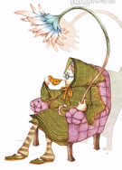 B. C.

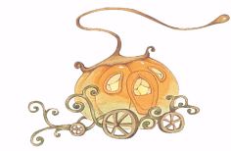( )3.What do the lizard and the mice become?

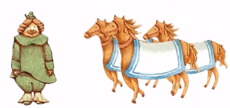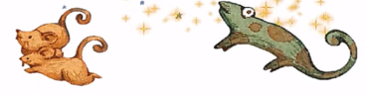A. B. C.

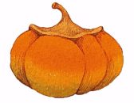( )4.What makes the prince find Cinderella?

1.  B. C.

( )5. “The stepmother and two sisters are very shocked.” What does the underlined mean?

1. 震惊的 B. 开心的 C.伤心的
2. **四、观看视频，用自己的话向家人说一说你这个故事。（尽可能英文，可中英结合）**