练习3
一．首字母填空。
1. Liu Tao has many bad h________, and he n________ goes to bed early.
2. His sister always f________ her homework early at weekends.
3. Please keep your room clean and t______.
4. I want to go to bed now because I feel s________.
二．二选一。
1. Mr. Liu always goes to work________ (well/early) in the morning.
2. Look! The boys are running_______ (late/fast).
3. You should put your things ____________(in order/in a mess).
4. I always have my meals ________(on/in) time.
5. Su Hai , _________(put/puts) your hands on the desk.
6. Su Hai _________(put/puts) her hands on the desk.
三．根据图片和上下文，补全对话。
A: ________ Wang Bing ________ a ________ habit?
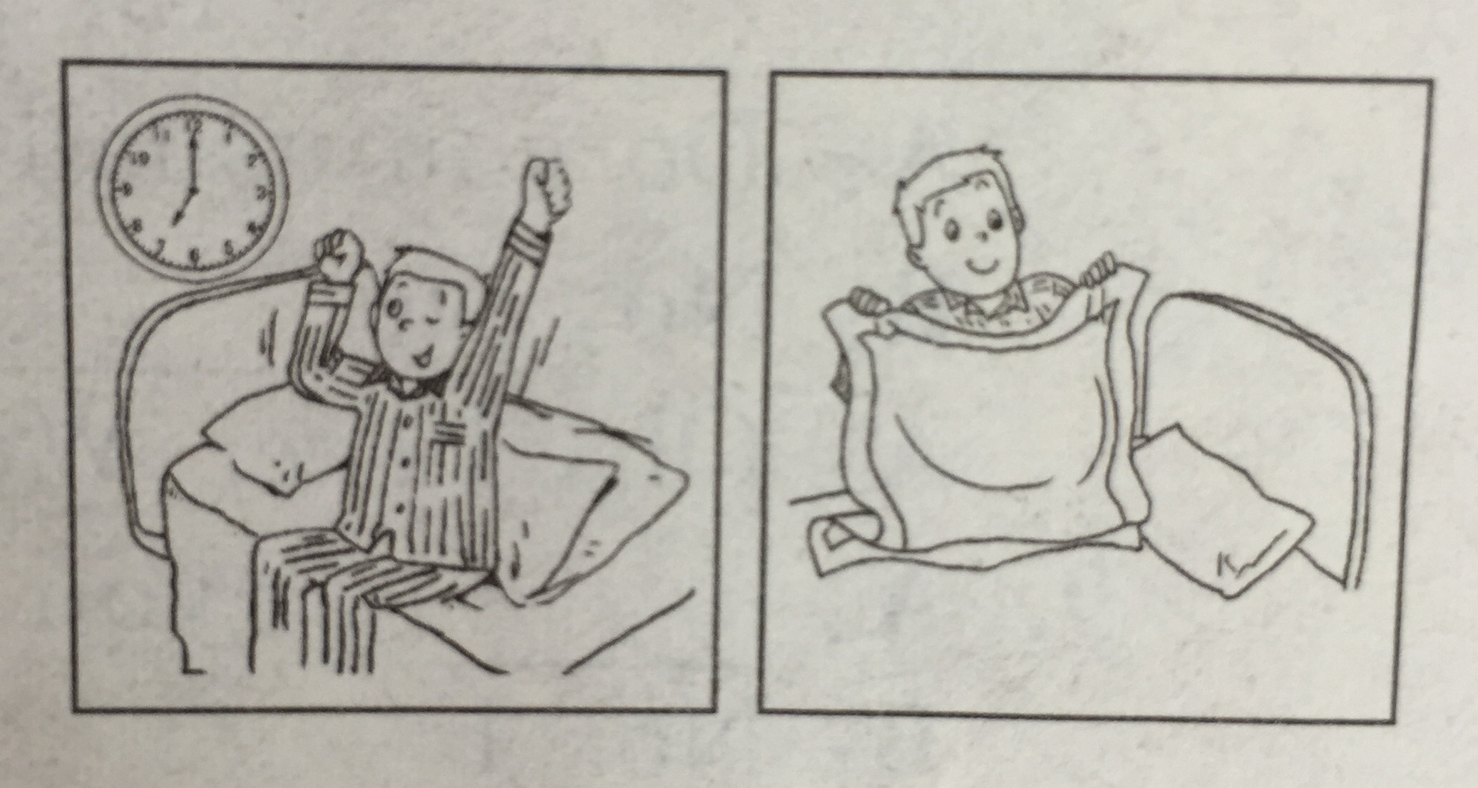
B: Yes, he____________.
A: _________ does he _________ _________
in the morning?
B: ____________ seven o’clock.
A: ____________ does he usually ____________ after breakfast?
B: He usually ____________ the ____________.
四．完形填空。
Our eyes are very important to us. They’re just like cameras ( 照相机 ). We can see beautiful things and colours around us 1 our eyes. But if we don’t take good care of them, they may hurt. 2 do we protect our eyes? On sunny days, the sun shines brightly. So we should 3 our sunglasses. When we read, we shouldn’t stay too close to our books and the light shouldn’t be too bright 4 too dark. We mustn’t read in bed. It’s 5 for our eyes. We mustn’t rub ( 揉 ) our eyes with dirty hands or play games on computer for a long time.
( ) 1. a with b for c of
( ) 2. a What b How c Who
( ) 3. a with b in c wear
( ) 4. a or b and c with
( ) 5. a bad b good c badly

