**The witch’s wall课后作业**

1. **[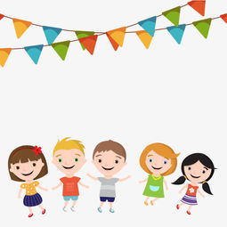](https://pic.sogou.com/d?query=%BA%A2%D7%D3%BF%A8%CD%A8%26mode=1%26did=6)看视频，将下列单词与图片释义连线，并在横线上写出中文意思。**

witch 女巫；巫婆 · ·

[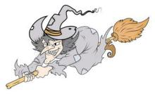](https://pic.sogou.com/d?query=%C5%AE%CE%D7%BF%A8%CD%A8%26mode=1%26did=53)

wall \_\_\_\_\_\_\_\_\_\_\_\_\_\_\_ · ·

[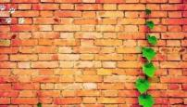](https://pic.sogou.com/d?query=%D7%A9%C7%BD%26mode=1%26did=87)

children \_\_\_\_\_\_\_\_\_\_\_\_\_\_\_ · ·

[](https://pic.sogou.com/d?query=%B4%F3%C9%BD%BF%A8%CD%A8%26mode=1%26did=42)

draw \_\_\_\_\_\_\_\_\_\_\_\_\_\_\_ · ·

[](https://pic.sogou.com/d?query=%CC%EC%BF%D5%BF%A8%CD%A8%B1%B3%BE%B0%CD%BC%26mode=1%26did=10)

sky \_\_\_\_\_\_\_\_\_\_\_\_\_\_\_ · ·

[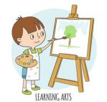](https://pic.sogou.com/d?query=%BB%AD%BB%AD%BF%A8%CD%A8%26mode=1%26did=7)

mountain \_\_\_\_\_\_\_\_\_\_\_\_\_\_\_ · ·

[C:/Users/91915/AppData/Local/Temp/kaimatting/20200309162804/output_aiMatting_20200309162809.pngoutput_aiMatting_20200309162809](https://pic.sogou.com/d?query=%BB%A8%BF%A8%CD%A8%26mode=1%26did=7)

sea \_\_\_\_\_\_\_\_\_\_\_\_\_\_\_ · ·

[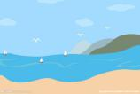](https://pic.sogou.com/d?query=%B4%F3%BA%A3%BF%A8%CD%A8%26mode=1%26did=1)

island \_\_\_\_\_\_\_\_\_\_\_\_\_\_\_ · ·

[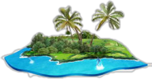](https://pic.sogou.com/d?query=%B5%BA%D3%EC%BF%A8%CD%A8%B1%B3%BE%B0%CD%BC%26mode=1%26did=80)

forest \_\_\_\_\_\_\_\_\_\_\_\_\_\_\_ · ·

[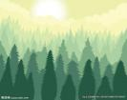](https://pic.sogou.com/d?query=%C9%AD%C1%D6%BF%A8%CD%A8%B1%B3%BE%B0%CD%BC%26mode=1%26did=380)

flower \_\_\_\_\_\_\_\_\_\_\_\_\_\_\_ · ·

1. **跟视频学习，并朗读上面的单词。**
2. **看视频，然后思考问题。（可中英文结合回答）**
3. Does the witch really not like the children? Why?

(巫婆是真的不喜欢小孩子们吗？为什么呢？)

1. Should we draw pictures on the wall without permission? Why?

(在没有被允许的情况下，我们可以在墙上画画吗？为什么呢？)