**The Magic Box 课后习题**

**一．生词释义（根据释义观看理解视频）**

magic 魔法；神奇的 show表演

put放 pop（意外地）出现；发出爆裂声

1. **观看视频，将下列单词与图片连线，并在横线上写出他们的意思。**
2. butter 黄油 fly butterfly

[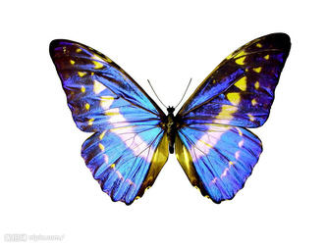](https://pic.sogou.com/d?query=%BA%FB%B5%FB%26mode=1%26did=7)

[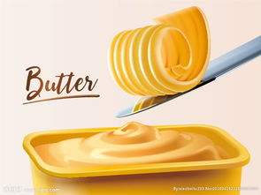](https://pic.sogou.com/d?query=%BB%C6%D3%CD%26mode=1%26did=70)[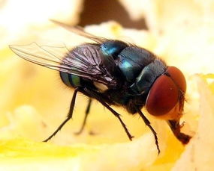](https://pic.sogou.com/d?query=%B2%D4%D3%AC%26mode=1%26did=8)

1. star fish starfish

[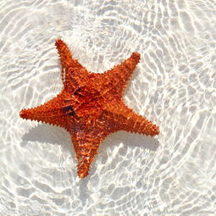](https://pic.sogou.com/d?query=%BA%A3%D0%C7%26mode=1%26did=24)[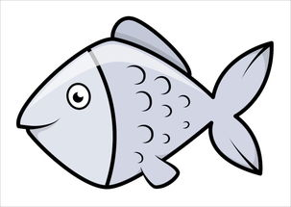](https://pic.sogou.com/d?query=%D3%E3%BF%A8%CD%A8%26mode=1%26did=6)

[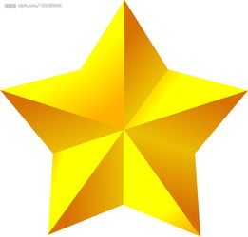](https://pic.sogou.com/d?query=%D0%C7%D0%C7%26mode=1%26did=293)

1. water melon watermelon

[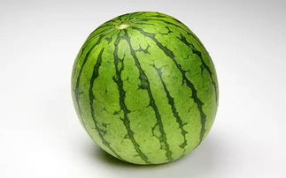](https://pic.sogou.com/d?query=%CE%F7%B9%CF%26mode=1%26did=67)[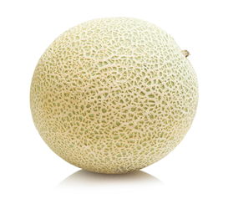](https://pic.sogou.com/d?query=melon%26mode=1%26did=4)[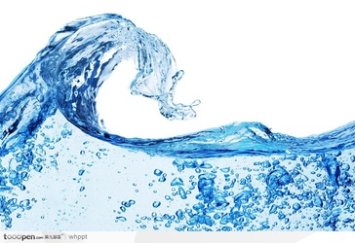](https://pic.sogou.com/d?query=%CB%AE%26mode=1%26did=3)

1. mail box mailbox

[](https://pic.sogou.com/d?query=%D0%C5%CF%E4%26mode=1%26did=2)

[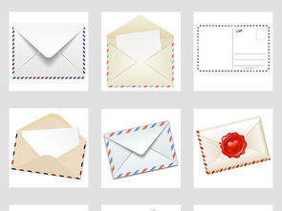](https://pic.sogou.com/d?query=%D0%C5%BC%FE%26mode=1%26did=7)

[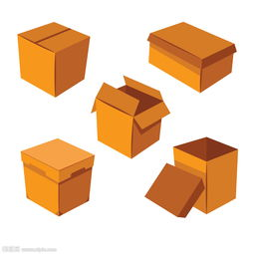](https://pic.sogou.com/d?query=%BA%D0%D7%D3%26mode=1%26did=15)

1. sun flower sunflower

[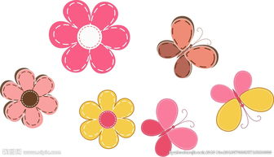](https://pic.sogou.com/d?query=%BB%A8%BF%A8%CD%A8%26mode=1%26did=30)[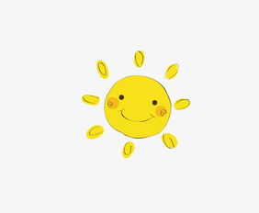](https://pic.sogou.com/d?query=%CC%AB%D1%F4%26mode=1%26did=16)[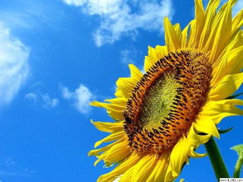](https://pic.sogou.com/d?query=%CC%AB%D1%F4%BB%A8%26mode=1%26did=85)

1. pop corn popcorn

[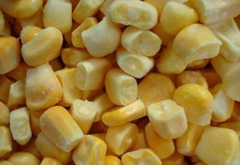](https://pic.sogou.com/d?query=corn%26mode=1%26did=90)[](https://pic.sogou.com/d?query=%B1%AC%C3%D7%BB%A8%26mode=1%26did=31)

1. **跟视频学习，朗读第一、二项单词。**
2. **想一想，你还知道哪些“A+B=AB”式的单词？请写出6个。**

**___________+____________=_____________**

**___________+____________=_____________**

**___________+____________=_____________**

**___________+____________=_____________**

**___________+____________=_____________**

**___________+____________=_____________**