绘本1 The Jungle book
视屏链接：
https://www.iqiyi.com/v_19rr4xpgk0.html

一：单词释意
jungle 丛林，密林 attack攻击 naked裸体的 grow up 成长
jaguar美洲虎 fearsome可怕的 protect 保护 show up 出现
strange 奇怪的，陌生的 take care of 照顾 language语言 wait for等待 a herd of 一群 buffalo 水牛 cheer for 为…欢呼

二：根据视频内容判断正误，正确的写T错误的写F
( )1. Mowgli’s mother and father don’t like him, so they throw（扔,丢弃） him into the jungle.
( )2. Mowgli swims, jumps and sings with his animal friends in the jungle.
( )3. The tiger is afraid of（害怕） fire（火）.
( )4. Mowgli leaves（离开） the jungle, because he wants to protect his animal friends.
( )5. Mowgli is happy in the village（村庄）.
( )6. The tiger is killed by（被···杀掉） Mowgli and his animal friends.

绘本2作业
视频链接： https://www.iqiyi.com/v_19rr4xph1c.html
- 观看绘本，根据释义理解绘本
mountain 山；山脉 rain下雨；雨水
bring 带来；带给 brought带来（bring的过去式） alone独自 got lost迷路；走丢
stop 停止 daughter女儿
sick 不舒服 smile微笑
listen听 star星星
take care of 照顾；照看 get married结婚

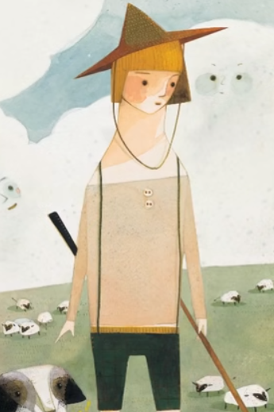
- 观看视频，选择正确答案
（ ）1.What did the shepherd’s friends bring him?
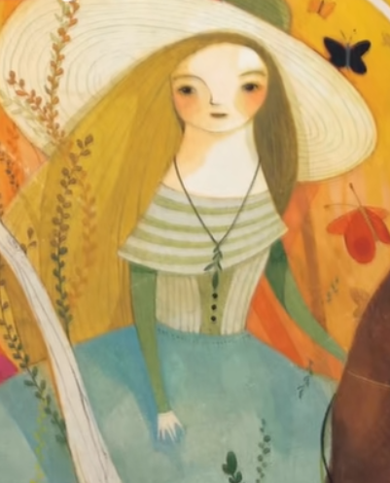
A .drinks B. food C.fruit
（ ）2. Why did Stephanette come late（来迟了）?

Because（因为）_______.
A. She got lost in the rain
B. . She got lost in the mountain
C. . She got lost in the forest
（ ）3.What is the most（最） beautiful star?
- Orion B.Sirius C.the shepherd

三．用自己的语言向家人说一说这个故事，可以中英文结合。

