**The crow and the fox**

**一．根据释义理解视频。**

bright morning明媚的早晨 flying around飞来飞去

a piece of cheese一块芝士 beg祈求 shearing分享

landed in a branch降落在一根树枝上 as beautiful as... 和···一样漂亮

immediately立刻；马上

How do you keep your feathers so lustruous?你是怎么保持你的羽毛这么有光泽的？

praising him夸奖他；赞美他 fool愚弄 thought the crow乌鸦想到

all you need is...你所需要的是··· singing voice好歌喉

the most amazing crow最不可思议的乌鸦 as if she were planning to leave假装她要离开

show off his voice一展歌喉 sing for the fox为狐狸高歌一曲

fell掉落 fallen for the fox’s trick落入狐狸的陷阱

too late太迟了

1. 观看理解视频，判断句子正误。

[](https://pic.sogou.com/d?query=%CF%C2%D3%EA%BF%A8%CD%A8%26mode=1%26did=3)

（ ） 1. It’s in the morning.

（ ）2.There is a piece of cake on the window sill.

[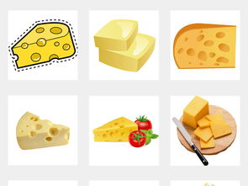](https://pic.sogou.com/d?query=%D6%A5%CA%BF%BF%A8%CD%A8%26mode=1%26did=272)[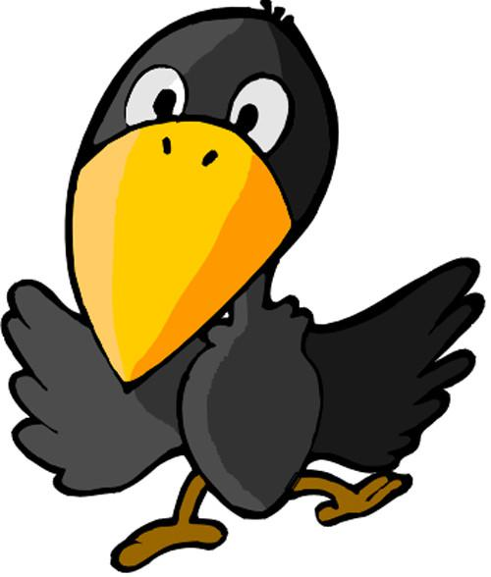](https://pic.sogou.com/javascript:void(0))

（ ）3. The decided to shear(分享) the with his friends.

[](https://pic.sogou.com/d?query=%D6%A5%CA%BF%BF%A8%CD%A8%26mode=1%26did=272)

（ ）4.The fox wants to eat the . So she tricked(欺骗) the crow.

[](https://pic.sogou.com/d?query=%D6%A5%CA%BF%BF%A8%CD%A8%26mode=1%26did=272)

（ ）5. The fox didn’t get the .

[](https://pic.sogou.com/javascript:void(0))

（ ）6. The isn’t very clever.